**Lab 03**

Tasks:

1. Investigate the impact of signal strength by incrementally increasing the signal power at the base station.
2. What is the optimal signal strength the base station may operate at?

**When Step Size = 1**

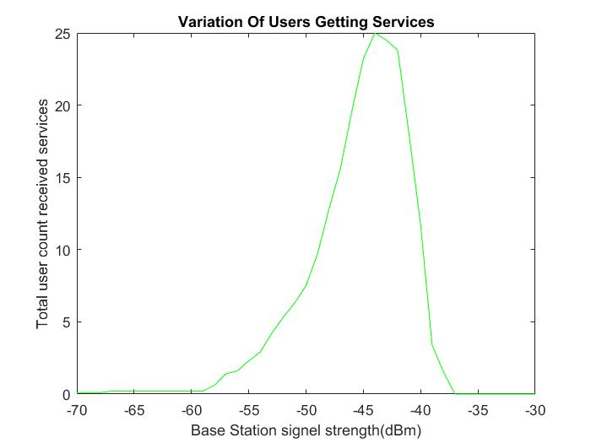

Max users 25 at -43.00 dBm

**When Step Size = 0.5**

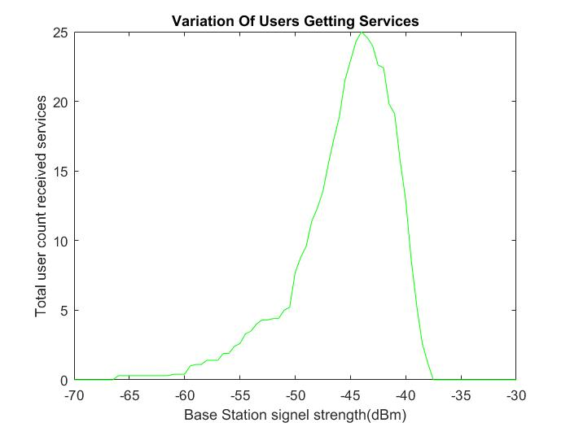

Max users 25 at -43.50 dBm

**When Step Size = 0.1**

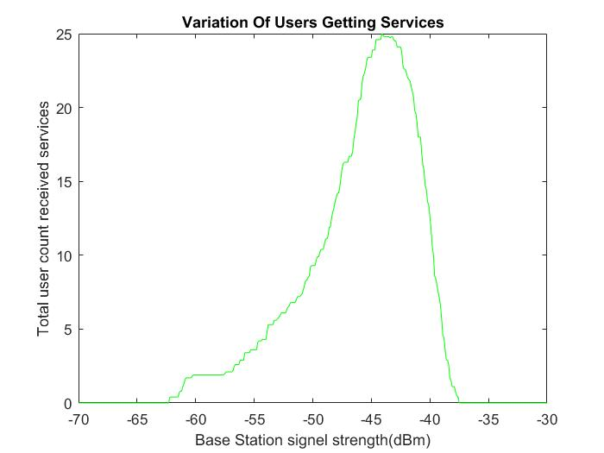

Max users 24 at -44.00 dBm

**When Step Size = 0.05**

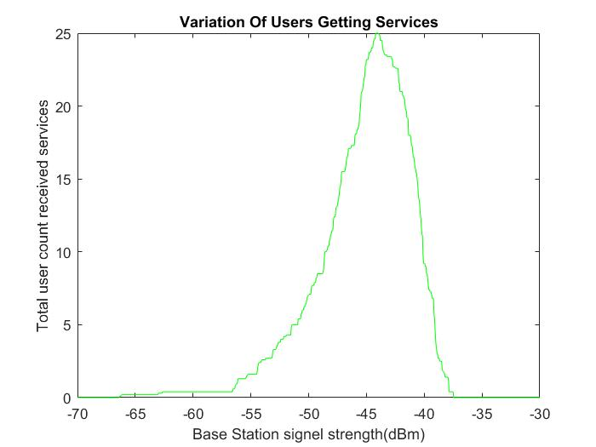

Max users 25 at -44.30 dBm